Building Early Reading Skills
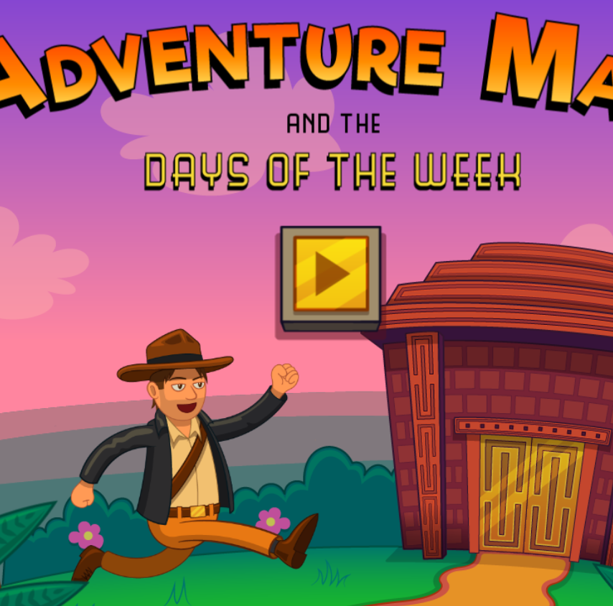
Adventure Man: Days of the Week
You can help Adventure Man find the treasure in the temple by completing these questions and tasks about the days of the week.
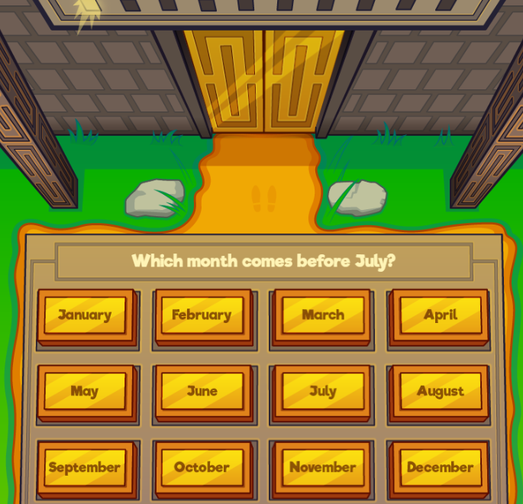
Adventure Man and the Months of the Year
Unlock the treasure with Adventure Man by completing some tasks about the months of the year.
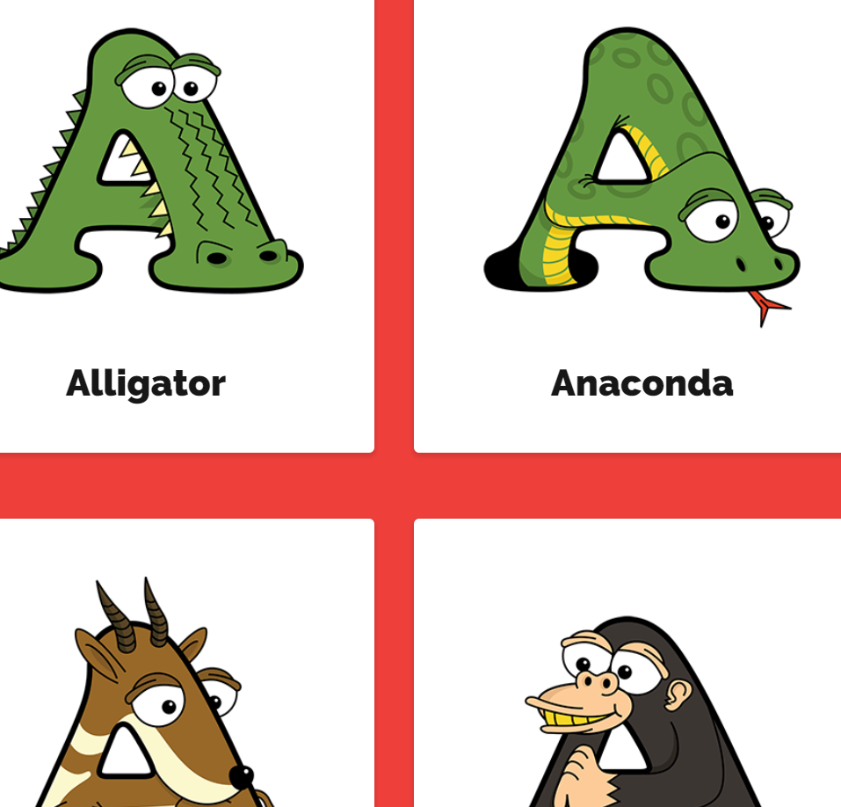
Alphabet'imals
Click on the letters to see animals that start with that letter. The animals all take the shape
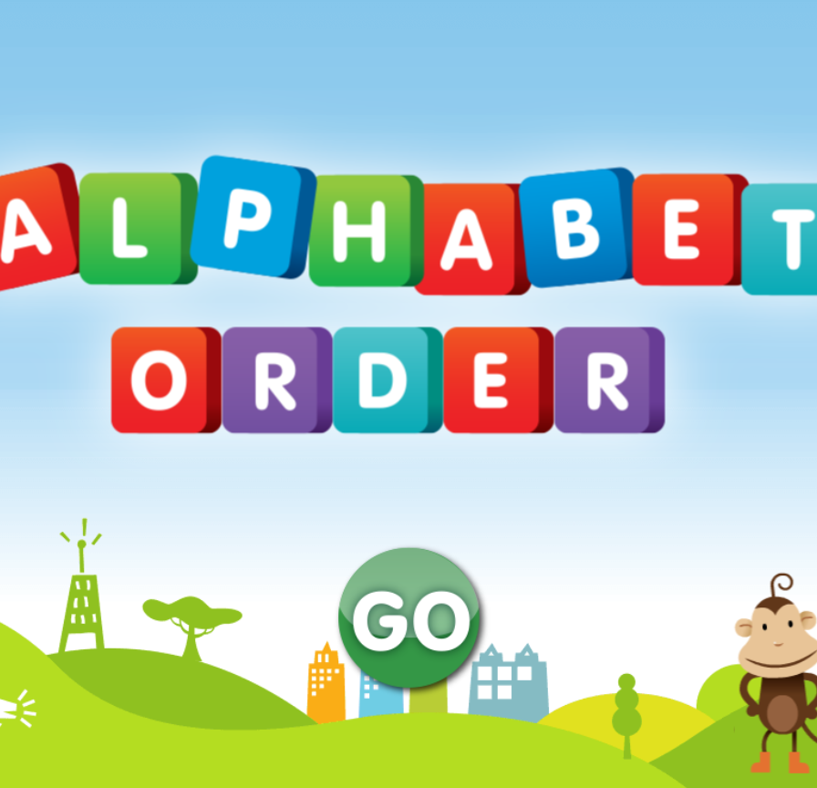
Alphabet Order
Help the monkey put the alphabet in order by dragging and dropping the blocks into place.
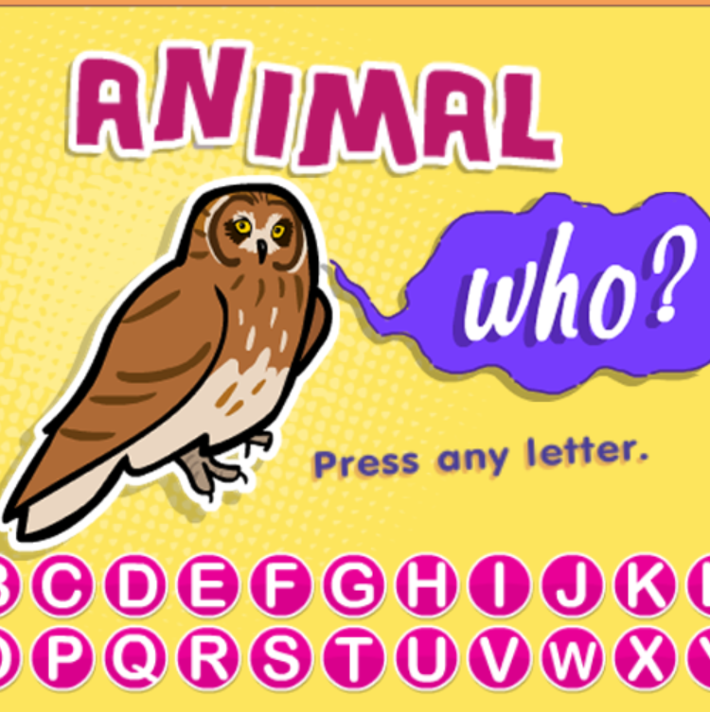
Animal Who?
Type a letter on your keyboard. When the animal appears, listen to the sound it makes and tell us what it is.
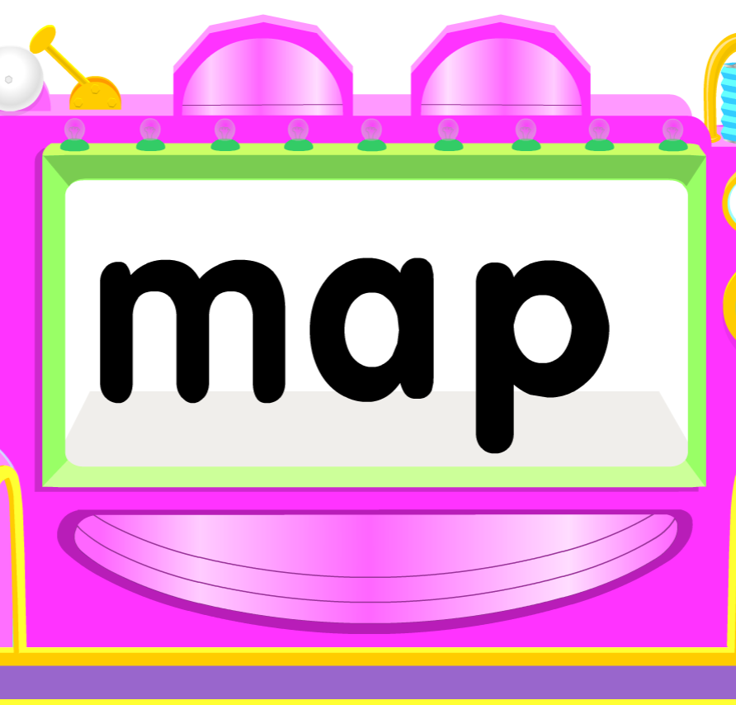
C-A-T Word Machines
Try these word machines to learn more about each sound. Pull on the levers to get new words.
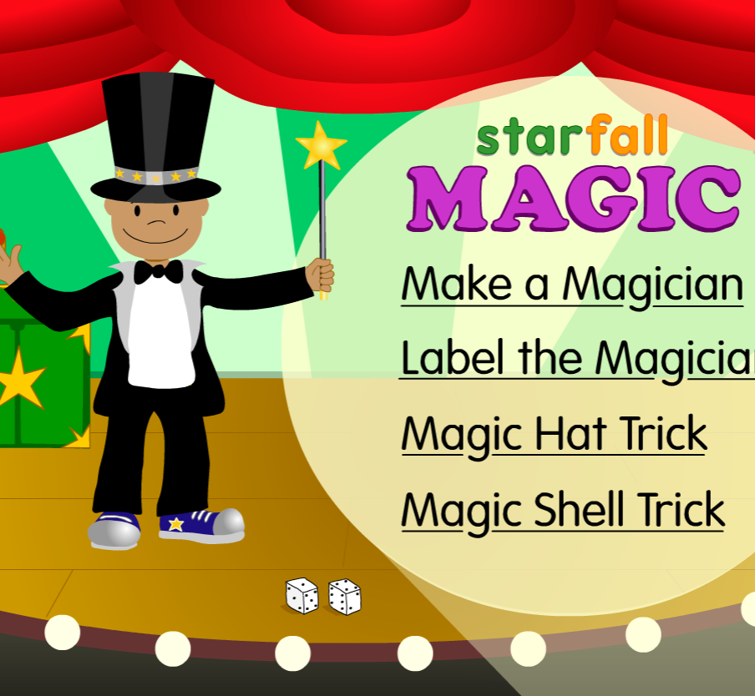
Magic!
Use your reading skills to create and label your magician. Try out some magic tricks.
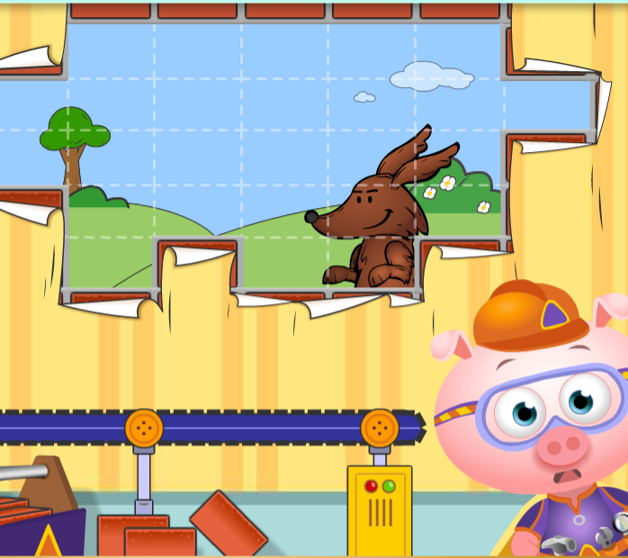
PBS Kids: Alphabricks
Storybrook Villages has a series of interactive stories that focus on early reading skills
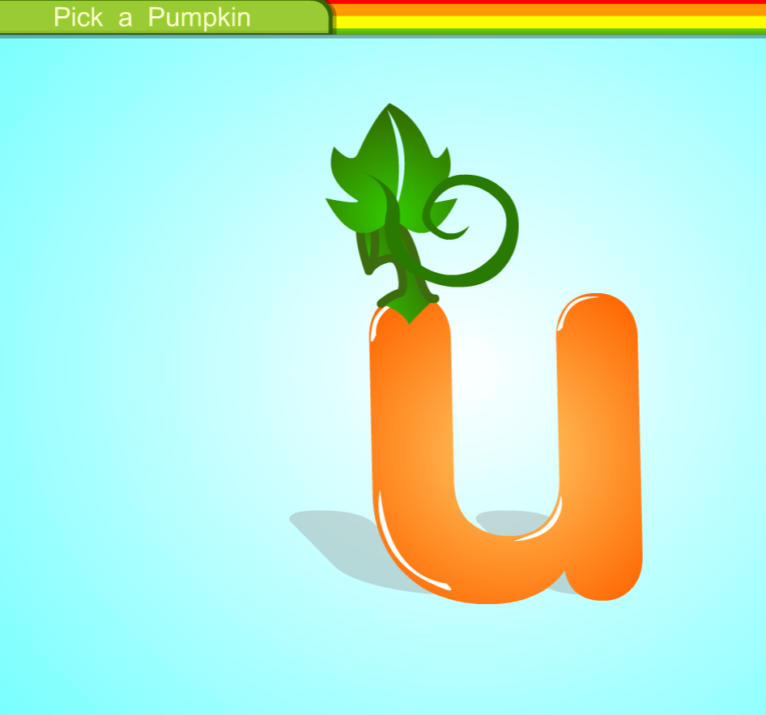
Pick a Pumpkin
Learn more about the sound a "u" makes as you pick and decorate a pumpkin for the fall harvest. Click on the words to hear the story read aloud.
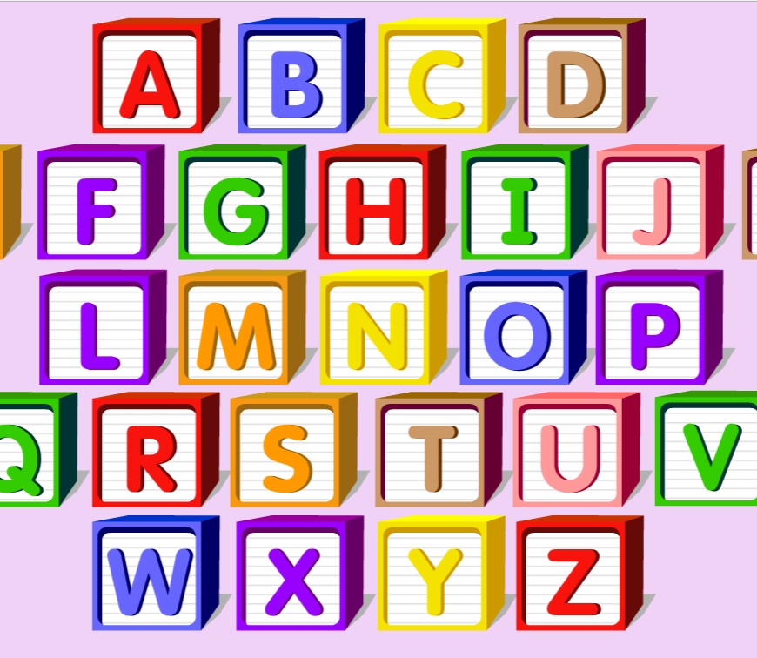
Starfall ABC's
Click on a letter to explore with fun songs and activities.
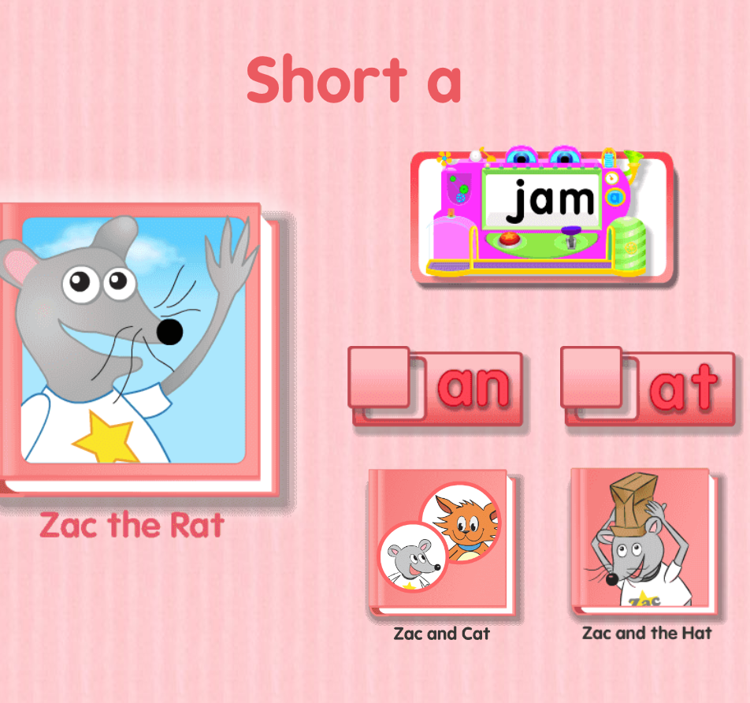
Zac the Rat Stories
Learn about the short vowel 'a' in these three short stories. Click on each scene to see Zac's actions. Click on the ear to hear the sentences read aloud.

